**OBSTACLE AVOIDING ROBOT**

By

P.KARTHIK 17BEC1142

T.JAYANTH KUMAR 17BLC1030

M.B.V.SRI HARSHA 17BEC1195

K.MADHU SEKHAR 17BEC1124

D.CHARAN 17BEC1208

K.MOUNISH NAIDU 17BEC1153

A project report submitted to

**Prof. Saranya Nair**

**SCHOOL OF ELECTRONICS ENGINEERING**

In partial fulfilment of the requirements for the course of

**ECE1005-SENSORS AND INSTRUMENTATION**

In

**B.Tech. ELECTRONICS AND COMMUNICATION ENGINEERING**

**&**

**B.Tech. ELECTRONICS AND COMPUTER ENGINEERING**



**Vellore Institute of Technology (VIT) CHENNAI**

**Vandalur – Kelambakkam Road**

**Chennai – 600127**

**MARCH 2018**

**BONAFIDE CERTIFICATE**

Is a bonafide work of **P. KARTHIK 17BEC1142**, **T.JAYANTH KUMAR 17BLC1030, M.B.V.SRI HARSHA 17BEC1195, K. MADHU SEKHAR 17BEC1124, D.CHARAN 17BEC1208, K.MOUNISH NAIDU 17BEC1153** who carried out the Project work under my supervision and guidance.

**Prof. Saranya Nair**

Associate Professor

School of Electronics Engineering (SENSE),

VIT University, Chennai

Chennai – 600 127.

**ABSTRACT**

*The purpose of this project is to develop a mobile robot with an obstacle avoidance capability. The mobile robot will be built with an onboard sensor to get information about the surrounding environment.*

*The mobile robot is a four wheeled robot platform. The robot has an ultrasonic sensor which is mounted in front of it to scan the front environment. The ultrasonic sensor will trigger a signal to the main controller, which is a PIC16F877A microcontroller.*

*The direction of the mobile robot will be controlled by one stepper motor that connected to the output of PIC16F877A microcontroller. The stepper motor will change the direction of mobile robot when an obstacle is detected. The other two wheels are dc motor which is only for motion purpose. The dc motor will be only run forward without influenced by the obstacle senses by ultrasonic sensor.*

**ACKNOWLEDGEMENT**

We wish to express our sincere thanks and deep sense of gratitude to our project guide, **Prof. SARANYA NAIR,** Associate Professor, School of Electronics Engineering, for his consistent encouragement and valuable guidance offered to us in a pleasant manner throughout the course of the project work.

We are extremely grateful to **Dr. Sreedevi. V.T,** Dean of the School of Electronics Engineering, VIT Chennai, for extending the facilities of the School towards our project and for her unstinting support.

We express our thanks to our Programme Chair **Dr. Vetrivelan.P** and Co-Chair **Prof.Reena Monica.P** for their support throughout the course of this project.

We also take this opportunity to thank all the faculty of the School for their support and their wisdom imparted to us throughout the course.

We thank our parents, family, and friends for bearing with us throughout the course of our project and for the opportunity they provided us in undergoing this course in such a prestigious institution.

**KARTHIK JAYANTH HARSHA MADHUSEKHAR**

**MOUNISH CHARAN**

**TABLE OF CONTENTS**

|  |  |  |  |
| --- | --- | --- | --- |
| **SERIAL NO.** |  | **NAME** | **PAGE NO.** |
|  |  | ABSTRACT | 3 |
|  |  |  |  |
|  |  |  |  |
| 1 |  | INTRODUCTION | 6 |
|  |  |  |  |
|  |  |  |  |
|  | 1.1 | BENEFITS | 6 |
|  | 1.2 | FEATURES | 7 |
|  |  |  |  |
| 2 |  |  |  |
|  | 2.1  2.2 | CIRCUIT ANALYSIS  EXPLANATION  OF CIRCUIT DIAGRAM | 8 |
|  | 2.3  2.4 | PIN CONNECTIONS  HARDWARE ANALYSIS | 9 |
|  |  |  |  |
|  |  |  |  |
|  |  |  |  |
| 3 | CONCLUSION | AND FUTURE WORK |  |
|  | 3.1 | CONCLUSION | 22 |
|  | 3.2 | FUTURE WORK |  |

4 REFERENCES 23

1. **INTRODUCTION**

**1.1 OBJECTIVES AND GOALS**

The purpose of this project is to develop a mobile robot with an obstacle avoidance capability. The mobile robot will be built as a fully autonomous vehicle with onboard sensor to get information about the surrounding environment.

The mobile robot is a three wheeled robot platform. The robot has an ultrasonic sensor which is mounted in front of it to scan the front environment. The ultrasonic sensor will trigger a signal to the main controller, which is a PIC16F877A microcontroller. The motion of the mobile robot will be controlled by one dc motor. The dc motor will change the direction of the mobile robot. The other two wheels is a dc motor which is only for motion purpose. The

stepper motor will be only run forward without influenced by the obstacle senses by ultrasonic sensor.

**1.2 BENEFITS**

Popular types of sensors for range-based obstacle detection systems includes ultrasonic sensors, laser range finders, radar, stereo vision, optical flow, and depth from focus. How, ever all these sensors have its own defects. Ultrasonic sensors are cheap comparing to other systems. Laser rangefinders and radar provide better resolution but are more complex and more expensive. Most depth from X vision systems require a textured environment to perform properly. Moreover, stereo vision and optical flow are computationally expensive.

Here we are designing a low cost obstacle detection robot that uses ultrasonic waves. The system basically comprises a transmitter section and a receiver section. Sounds up to 20kHz are audible for human, sounds above 20kHz are inaudible and are called Ultrasonic sound.

It can be used in vehicles. So, that the sensor detects the obstacle and reduces the car speed and further deviates from the direction it is going mainly this is to decrease number of accidents. It can be used in military weapons so as to detect the target and can change its direction so as not to be effected from the target. For example brahmos missile.

**1.3 FEATURES**

* Compact and light weight
* High sensitivity and high pressure
* High reliability
* Power consumption of 20mA
* Internally frequency compensation Wide output voltage swing ­1.5 V Common mode input voltage range includes V­ Wide supply voltage range 30 V (Single) 15 V (Split) Output short circuit protection
* Wide Supply-Voltage Range: 4.5 V to 36 V
* Separate Input-Logic Supply

**2. CIRCUIT ANALYSIS**

It mainly consists of Transmitter section and a receiver section. Receiver section is an IC .

**Basic principle of operation of ULTRASONIC sensor:**

An ultrasonic sensor typically utilizes a transducer that produces an electrical

Output in response to received ultrasonic energy. The normal frequency range for human hearing is roughly 20 to 20,000 hertz. Ultrasonic sound waves are sound waves that are above the range of human hearing and, thus, have a frequency above about 20,000 hertz.

Any frequency above 20,000 hertz may be considered ultrasonic.

Most industrial processes, including almost all sources of friction, create some

Ultrasonic noise. The ultrasonic transducer produces ultrasonic signals. These signals are propagated through a sensing medium and the same transducer can be used to detect returning signals.

Ultrasonic sensors typically have a piezoelectric ceramic transducer that converts an excitation electrical signal into ultrasonic energy bursts. The energy bursts travel from the ultrasonic sensor, bounce off objects, and are returned toward the sensor as echoes. Transducers are devices that convert electrical energy to mechanical energy, or vice versa. The transducer converts received echoes into analog electrical signals that are output from the transducer.

Ultrasonic transducers operate to radiate ultrasonic waves through a medium

such as air. Transducers generally create ultrasonic vibrations through the use of

piezoelectric materials such as certain forms of crystals or ceramic polymers.

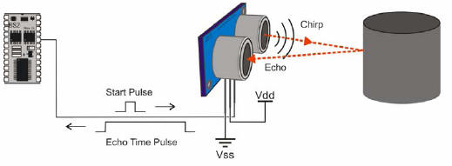

**Measurement Principle / Effective Use of Ultrasonic Sensor:**

Ultrasonic sensors transmit ultrasonic waves from its sensor head and again receive the ultrasonic

waves reflected from an object. By measuring the length of time from the transmission to reception of the

sonic wave, it detects the position of the object.



**The advantages of Ultrasonic sensor**

**Ultrasonic sensor has some advantages which are;**

i. Measures and detects distances to moving objects.

ii. Impervious to target materials, surface and color.

iii. Solid-state units have virtually unlimited, maintenance-free lifespan.

iv. Detects small objects over long operating distances.

v. Resistant to external disturbances such as vibration, infrared radiation, ambient noise and EMI

radiation.

vi. Ultrasonic sensors are not affected by dust, dirt or high-moisture environments.

vii. Discrete distances to moving objects can be detected and measured.

viii. Less affected by target materials and surfaces, and not affected by color. Solid-state units have

virtually unlimited, maintenance free life. Can detect small objects over long operating distances.

**The disadvantages of Ultrasonic sensor**

Some disadvantages of ultrasonic sensor are;

i. Overheating of a wave emitter precludes the energy of ultrasonic waves emitted there from being enhanced to a practical level.

ii. Interference between the projected waves and the reflected waves takes place, and development of standing waves provides adverse effects.

iii. It is impossible to discern between reflected waves from the road surface and reflected waves from

other places or objects.

iv. There is no effective measure for removing the influences of factors other than road surface irregularities such as, for example, winds, temperature variations, etc., which can change the intensity of reflected waves.



**PIC16F877A Microcontroller**

This is the main controller of the mobile robot. When the robot is turned on, the main controller is ready to receive an obstacle scanned by the ultrasonic sensor. Once the data is received, it will be placed into the conventional potential field algorithm as described earlier. This algorithm will decide the directionto which the mobile robot should turn. Then the appropriate signal will be sent to the servo motor to get the desired direction.

A microcontroller is an amazingly useful device. Akin to a very specialized

CPU, a microcontroller is small, consumes very little power, and can be programmed to quickly and reliably perform a wide variety of tasks.

Microcontrollers can be found in things used every day such as microwaves, remote controls, and vending machine. Programming a microcontroller, however, can often be frustrating. A developer has no way to look inside of the chip to see what is going on while his code is running, making

debugging very difficult without the aid of expensive equipment (in the range of

thousands of dollars).

Furthermore, microcontrollers must traditionally be programmed, or “burned,” with the code they are to run. This requires a special piece of equipment to do and requires that the chip be taken out of the circuit it is being used in, placed into the programmer, have data “burned” to it (which can take several minutes), then be replaced back in the circuit.

This process is time consuming and risky, as the pins on a microcontroller are easily bent out of their proper position. A special piece of code, called a boot loader, can alleviate the problem of having to use an external programmer to program and test code.

One basic application of PIC microcontrollers is their use to control motion based on input from a sensor. This is applicable to many different fields, from manufacturing to aeronautics to robotics.



The figure shows the pin connection of the PIC16F877A.

PIC16F873A/876A devices are available only in 28-pin packages, while PIC16F874A/877A devices are available in 40-pin and 44-pin packages. All devices in the PIC16F87XA family share common architecture with the following differences:

i) The PIC16F873A and PIC16F874A have one-half

a. of the total on-chip memory of the PIC16F876A

b. and PIC16F877A

ii) The 28-pin devices have three I/O ports, while the

a. 40/44-pin devices have five

iii) The 28-pin devices have fourteen interrupts, while

a. the 40/44-pin devices have fifteen

iv) The 28-pin devices have five A/D input channels,

a. while the 40/44-pin devices have eight

v) The Parallel Slave Port is implemented only on

a. the 40/44-pin devices



**DC Motor:**

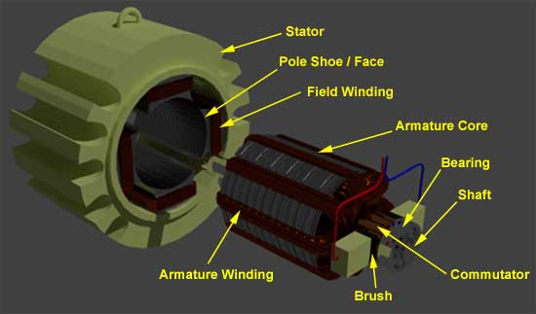

An **electric motor** converts electrical energy into mechanical energy. The

reverse process that of converting mechanical energy into electrical energy is

accomplished by a generator or dynamo. Traction motors used on locomotives often perform both tasks if the locomotive is equipped with dynamic brakes. Electric motors are found in household appliances such as fans, refrigerators, washing machines, pool pumps, floor vacuums, and fan-forced ovens.

Most electric motors work by electromagnetism, but motors based on other

electromechanical phenomena, such as electrostatic forces and the piezoelectric effect, also exist. The fundamental principle upon which electromagnetic motors are based is that there is a mechanical force on any current-carrying wire contained within a magnetic field. The force is described by the Lorentz force law and is perpendicular to both the wire and the magnetic field. Most magnetic motors are rotary, but linear motors also exist. In a rotary motor, the rotating part (usually on the inside) is called the rotor, and the stationary part is called the stator. The rotor rotates because the wires and magnetic field are arranged so that a torque is developed about the rotor’s axis. The motor contains electromagnets that are wound on a frame. Though this frame is often called the armature, that term is often erroneously applied. Correctly, the armature is that

part of the motor across which the input voltage is supplied. Depending upon the design of the machine, either the rotor or the stator can serve as the armature.

The principle of conversion of electrical energy into mechanical energy by

electromagnetic means was demonstrated by the British scientist Michael Faraday in 1821 and consisted of a free-hanging wire dipping into a pool of mercury. A permanent magnet was placed in the middle of the pool of mercury. When a current was passed through the wire, the wire rotated around the magnet, showing that the current gave rise to a circular magnetic field around the wire. This motor is often demonstrated in school physics classes, but brine (salt water) is sometimes used in place of the toxic mercury. This is the simplest form of a class of electric motors called homopolar motors. A later refinement is the Barlow’s Wheel. These were demonstration devices, unsuited to practical applications due to limited power.

**Voltage Regulator:**



Referring to the figure , voltage regulator is used to provide regulated 5V to power the PIC16F877A microcontroller. This is very essential since the microcontroller will blow if the voltage supplied to it is exceeding its voltage rating.



Voltage regulators comprise a class of widely used ICs. Regulator IC units contain the circuitry for reference source, comparator amplifier, control device and overload protection all in a single IC. Although the internal construction of the IC is somewhat different from that described for discrete voltage regulator circuits, the external operation is much the same. IC unit provide regulation of a fixed positive voltage, a fixed negative voltage or an adjustably set voltage.

A power supply can be built using a transformer connected to the ac supply line to step the ac voltage to desired amplitude, then rectifying that ac voltage, filtering with a capacitor and RC filter, if desired, and finally regulating the dc voltage using an IC regulator. The regulators can be selected for operation with load currents from hundreds of mill amperes to tens of amperes, corresponding to power ratings from milliwats to tens of watts.

**L293D**

L293D is a typical Motor driver or Motor Driver IC which allows DC motor to drive on either direction. L293D is a 16-pin IC which can control a set of two DC motors simultaneously in any direction. It means that you can control two DC motor with a single L293D IC.

The l293d can drive small and quiet big motors as well.

It works on the concept of H-bridge. H-bridge is a circuit which allows the voltage to be flown in either direction. As you know voltage need to change its direction for being able to rotate the motor in clockwise or anticlockwise direction, Hence, H-bridge IC are ideal for driving a DC motor.

In a single l293d chip there two h-Bridge circuit inside the IC which can rotate two dc motor independently. Due its size it is very much used in robotic application for controlling DC motors. Given below is the pin diagram of a L293D motor controller.

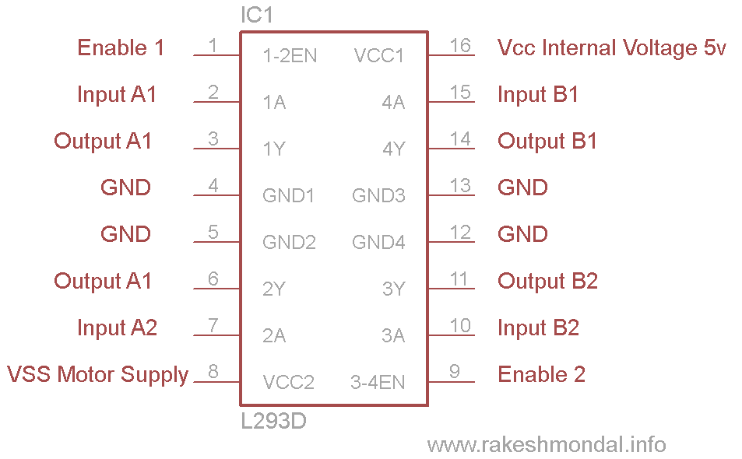

There are two Enable pins on l293d. Pin 1 and pin 9, as shown in figure 5, for being able to drive the motor, the pin 1 and 9 need to be high. For driving the motor with left H-bridge you need to enable pin 1 to high. And for right H-Bridge you need to make the pin 9 to high. If anyone of the either pin1 or pin9 goes low then the motor in the corresponding section will suspend working. It’s like a switch.

There are 4 input pins for this l293d, pin 2.7 on the left and pin 15 on the right as shown on the pin diagram. Left input pins will regulate the rotation of motor connected across left side and right input for motor on the right hand side. The motors are rotated on the basis of the inputs provided across the input pins as LOGIC 0 or LOGIC 1.

In simple you need to provide Logic 0 or 1 across the input pins for rotating the motor.

Let’s consider a Motor connected on left side output pins (pin 3.6). For rotating the motor in clockwise direction, the input pins have to be provided with Logic 1 and Logic 0.

• Pin 2 = Logic 1 and Pin 7 = Logic 0 | Clockwise Direction

• Pin 2 = Logic 0 and Pin 7 = Logic 1 | Anticlockwise Direction

• Pin 2 = Logic 0 and Pin 7 = Logic 0 | Idle [No rotation] [Hi-Impedance state]

• Pin 2 = Logic 1 and Pin 7 = Logic 1 | Idle [No rotation]

In a very similar way the motor can also operate across input pin 15 for motor on the right-hand side.

**CIRCUIT DIAGRAM**

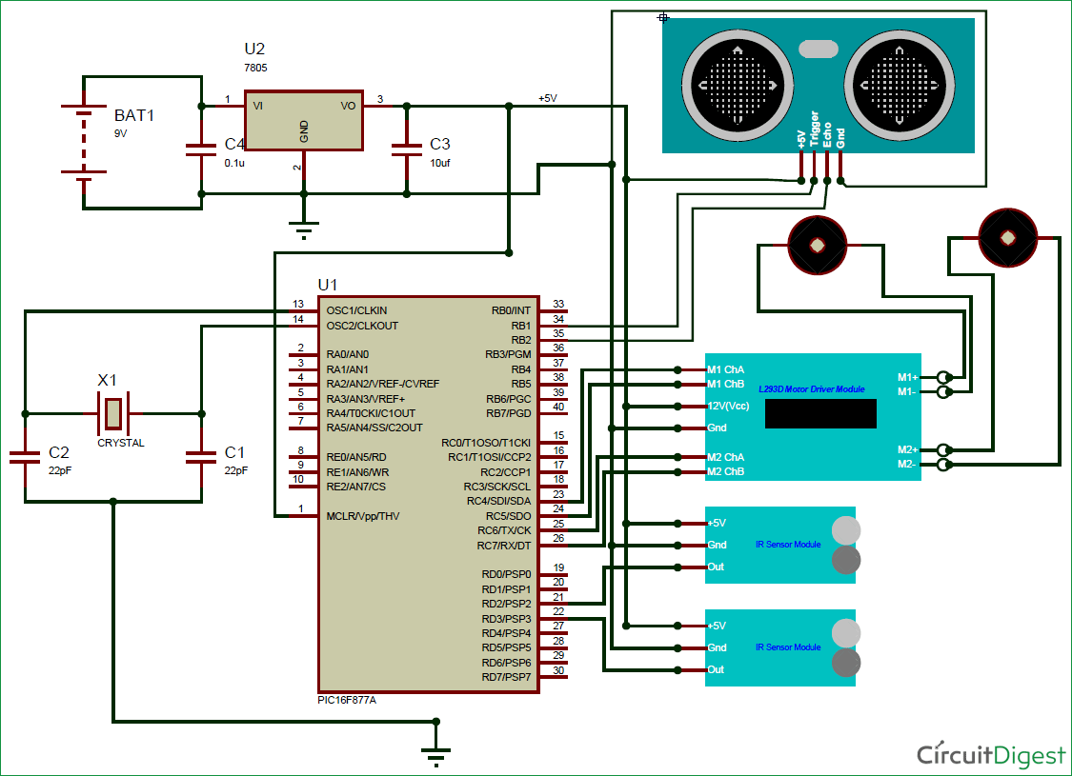

**3. CONCLUSION AND FUTURE WORK**

**CONCLUSION**

* Obstacle detection robot was built and implemented.
* The system is targeted at obstacles.
* The robot developed can detect obstacles at a certain range.
* The robot detects the obstacle and deviates from its path.

**FUTURE WORK**

* The Ultrasonic sensor can also be used in such a way that if a missile is locked on any car by using ultrasonic sensor the car can move away from the obstacle.
* By using more ultrasonic sensors we can cover the detection the obstacles around the object.
* Ultrasonic waves are less diffused and it can pass through high density substances so it can be used in detecting the targets by submarine or ships.

**4. REFERENCES**

1. www.google.com
2. [www.ti.com](http://www.ti.com)
3. [www.circuitstoday.com](http://www.circuitstoday.com)
4. [www.fadooengineers.com](http://www.fadooengineers.com)
5. [www.electroschematics.com](http://www.electroschematics.com)
6. [www.engineersgarage.com](http://www.engineersgarage.com)
7. [www.wikipedia.com](http://www.wikipedia.com)
8. [www.electrosome.com](http://www.electrosome.com)